Hackathon Project Phases Template for the Briding imagination and Reality in Fashion Design with stable Diffusion project

Hackathon Project Phases Template

Project Title:
Bridging Imagination and Reality in Fashion Design with Stable Diffusion

Team Name:
Digital Design

Team Members:
- Hema Latha Annaboina
- Rajitha Arakatla
- Venkata Lavanya Katteboyina
- Haripriya Katteboyina
- Yagna Sri Kolla

Phase-1: Brainstorming & Ideation

Objective:
- To help people easily see what their own clothing designs would look like.To make online fashion shopping more fun and creative by bringing imagination to life.
- CoutureAI wants to make it easier for people to see what their dream clothes would look like. It uses a special computer program to create realistic images of clothes based on what people describe.Be more creative with their clothing designs,Feel more confident about the clothes they create and Have more fun shopping for clothes online.

Key Points:
- Problem Statement:
It's tough for people to see what their own clothing designs will actually look like. Online stores don't usually let you create pictures of your unique style ideas. CoutureAI is here to fix that!
- Proposed Solution:
To help people easily see what their own clothing designs would look like.To make online fashion shopping more fun and creative by bringing imagination to life.
- Target Users: Fashion enthusiasts who enjoy experimenting with different styles and designs. Online shoppers who want to visualize clothing items before making a purchase.
- Expected Outcome: Help people see their unique fashion ideas as real pictures.Connect what you imagine with what you can actually wear.

Phase-2: Requirement Analysis

Objective:
  - To figure out exactly what users need so CoutureAI can create amazing pictures of their clothing ideas.To make sure CoutureAI is super easy and fun to use for everyone who loves fashion!

Key Points:
- Technical Requirements: Python is the main language, kind of like the secret ingredient for the whole thing. Streamlit makes it super simple for you to tell CoutureAI what you want, like a friendly helper.
- Functional Requirements: Let you easily describe the clothes you're dreaming up.Create realistic pictures of those clothes based on your descriptions.Show you those pictures in a way that's fun and easy to look at.
- Constraints & Challenges: Nobody wants to wait ages for a picture to pop up. CoutureAI needs to be fast so you can see your designs quickly. There are tons of clothing styles out there! CoutureAI needs to be able to handle everything from funky streetwear to elegant evening gowns.

Phase-3: Project Design

Objective:
  - Develop the architecture and user flow of the application.

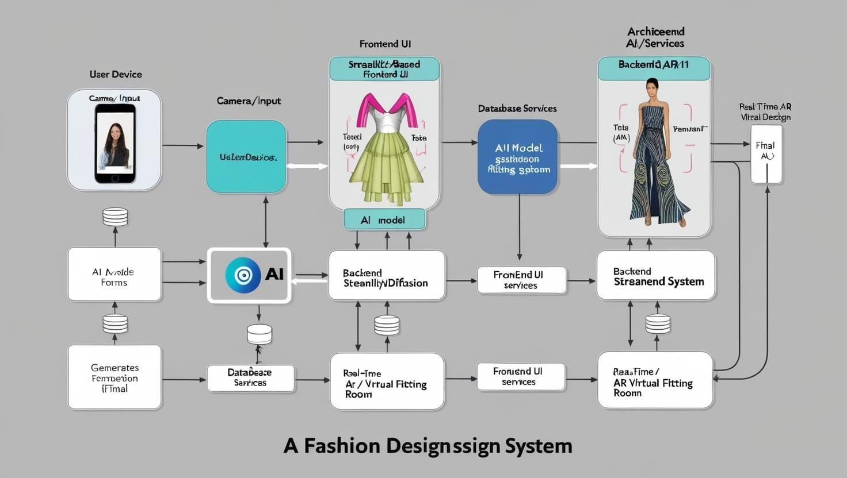
Key Points:
- System Architecture Diagram:
User Device: Input descriptions or upload photos.
Frontend (Streamlit): Interface for users to interact.
Backend: Processes input and sends data to the AI (Stable Diffusion) for design generation.
AI Model (Stable Diffusion): Generates clothing design.
AR (Virtual Fitting Room): Projects designs onto user's body in real-time.Final Display: Shows design with AR overlay for customization or purchase
- User Flow:
Open App: User accesses CoutureAI.
Input Description: User enters a clothing description or uploads a photo.
AI Generates Design: Backend processes input and generates clothing design via AI.
Virtual Fitting Room (AR): User tries on clothing virtually using AR.
Customization: User tweaks design and sees real-time updates.
Final Design: Save or purchase design
- UI/UX Considerations:
Homepage: Simple interface with description input, camera/upload option, and submission button.
Design View: Shows generated design with customization options and AR button.
AR Page: Virtual fitting room with real-time body overlay, and controls for design adjustments.
Minimalist and Interactive: Easy navigation, real-time updates, and mobile responsiveness for a smooth experience.

Phase-4: Project Planning (Agile Methodologies)

Objective:
  - Break down the tasks using Agile methodologies.
Sprint | Task | Priority | Duration | Deadline | Assigned To | Dependencies | Expected Outcome
Sprint 1 | Environment Setup & API Integration | 🔴 High | 6 hours (Day 1) | End of Day 1 | Member 1 | Google API Key, Python, Streamlit setup | API connection established & working
Sprint 1 | Frontend UI Development | 🟡 Medium | 2 hours (Day 1) | End of Day 1 | Member 2 | API response format finalized | Basic UI with input fields ready
Sprint 2 | Clothing Design Generation | 🔴 High | 3 hours (Day 2) | Mid-Day 2 | Member 1 & 2 | API response, UI elements ready | Design generation feature implemented
Sprint 2 | AR Try-On Feature Integration | 🔴 High | 4 hours (Day 2) | End of Day 2 | Member 3 | AR SDK setup, Design Generation | AR virtual fitting room implemented
Sprint 3 | Testing & Debugging | 🔴 High | 2 hours (Day 3) | Mid-Day 3 | Member 2 & 3 | AR & Design Generation features | Bug fixes and testing completed
Sprint 3 | UI/UX Enhancements | 🟡 Medium | 1.5 hours (Day 3) | Mid-Day 3 | Member 1 & 2 | UI/UX designs, AR feature testing | Improved UI, better user experience
Sprint 3 | Final Presentation & Deployment | 🟢 Low | 1 hour (Day 3) | End of Day 3 | Entire Team | Project readiness | Demo-ready working prototype

Key Points:

- Sprint Planning: Team defines and commits to a set of tasks (user stories) to complete during a sprint (typically 1-4 weeks).
- Task Allocation: Team members volunteer for tasks or are assigned by the Scrum Master.Tasks are allocated based on skills, expertise, and workload. Each task is estimated and assigned a specific deadline.
- Timeline & Milestones: Iterative development with fixed-length sprints (e.g., 2-4 weeks).
& Specific goals achieved at the end of each sprint or release.

Phase-5: Project Development

Objective:
To build a cool tool that lets people see their dream clothes before they're made!.

Key Points:
- Technology Stack Used: Python: This is the programming language that serves as the foundation for CoutureAI. It's like the glue that holds everything together and allows the different parts of the system to communicate with each other.
- Development Process: First, we plan out all the cool features CoutureAI will have.Then, we build the app and test it to make sure it works great. Finally, we share CoutureAI with everyone so they can design awesome clothes!
- Challenges & Fixes: Getting the computer to understand exactly what you mean by "sparkly" or "flowy"—Fix: We're training it with tons of examples! Challenge: Making the pictures appear super fast so you don't have to wait—Fix: We're using some clever tech tricks to speed things up.

Phase-6: Functional & Performance Testing

Objective:

Ensure that the CoutureAI app works as expected, focusing on functionality, performance, bug fixes, and deployment readiness.

Key Points:
- Test Cases Executed: Text-to-Image Generation: Verify realistic image output from text descriptions.Test image clarity, detail, and texture. Customization Options: Validate image rendering with different colors, fabrics, and styles.AR Try-On Feature: Ensure realistic rendering of clothing items on user photos.
- Bug Fixes & Improvements: Fixed bug where design generation was delayed. AI-generated design should appear within 5 seconds. Fixed Developer
- Final Validation: Validate user customization options (e.g., color, style) User inputs should correctly reflect in the AI-generated design. Passed Tester 1
- Deployment (if applicable): Host the app using Streamlit Sharing App should be accessible online via the provided link. Deployed DevOps

Final Submission
- Project Report Based on the templates
- Demo Video (3-5 Minutes)
- GitHub/Code Repository Link
- Presentation

